**PROJECT REPORT TEMPLATE**

**1.INTRODUCTION**

1.1 OVERVIEW

My project name is ,UrbanAura Interiors(Interior Designing -Industry. UrbanAura Interiors , a Interior Designing company uses Zoho books to effectively manage their financial processes, maintain accurate records, and make informed financial decisions. This integration enhances their overall business efficiency and contributes to their success in the interior design industry.

1.2 PURPOSE

The urban interior style merges industrial with contemporary design, creating a modern, bohemian look. You'll see concrete floors, exposed timber beams, steel, and unfinished surfaces. Sophisticated finishes and high-end bespoke fixtures makes the Urban look more expensive and polished

.

**2.PROBLEM DEFINITION & DESIGN THINKING**

2.1 Empathy Map

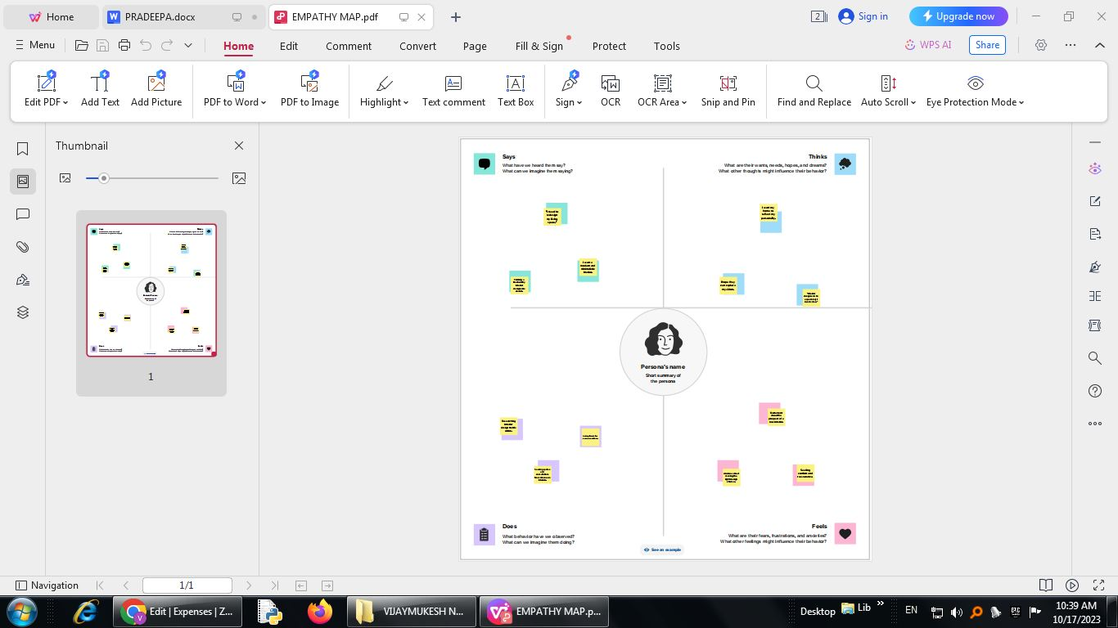

**2.2 Ideation & Brainstroming map**

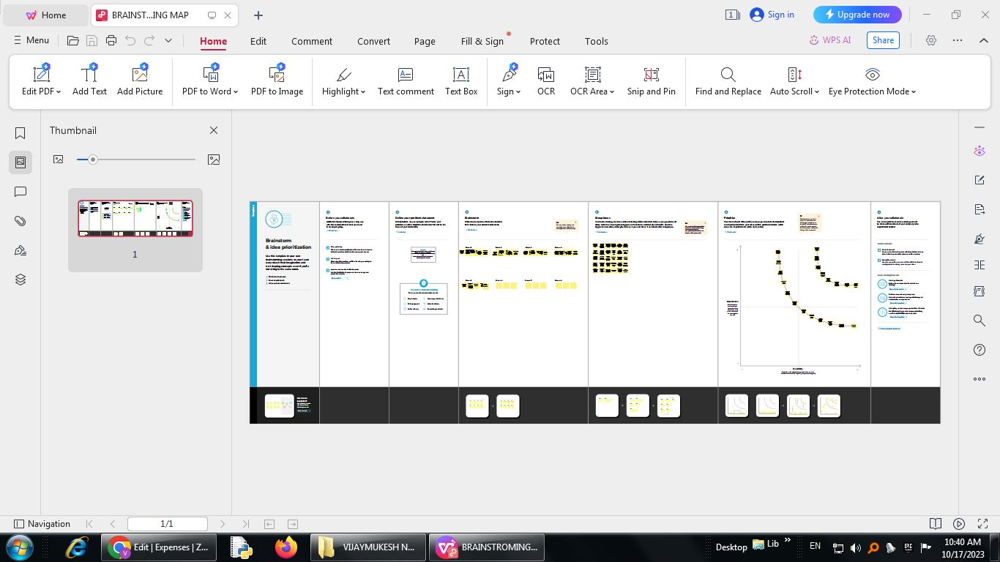

**3.RESULT**

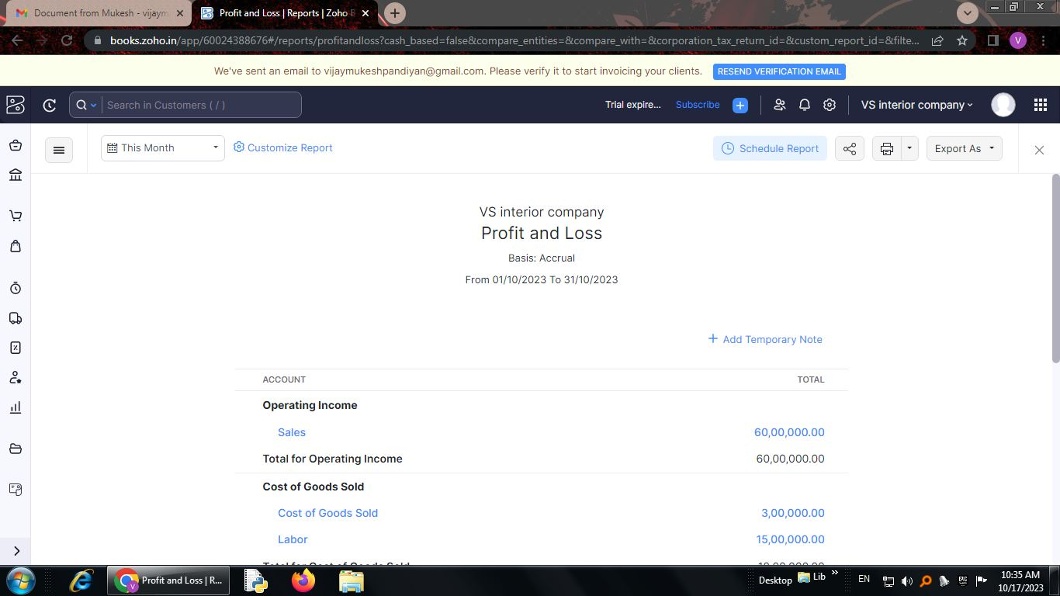

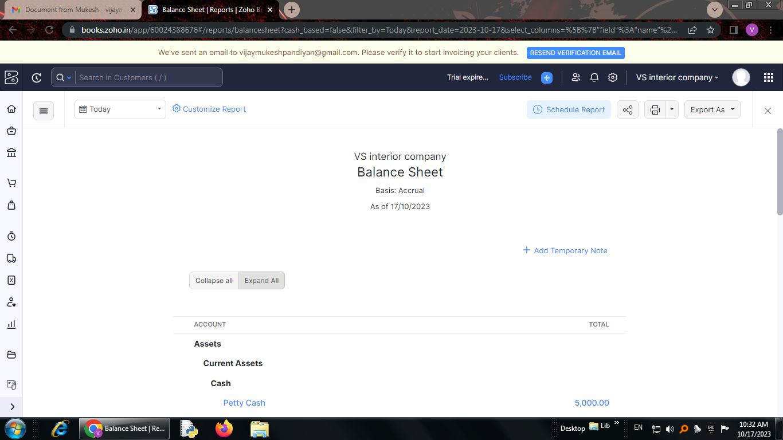

**4. ADVANTAGES & DISADVANTAGES**

**Advantages:**

With a 13% career growth expected in the next decade, the career options and diversity in the field of interior design are captivating. With the growing demand for interior design as a career and as an art, the relevance of the field in contemporary artistic expression has reached a strong point. An interior designer is provided with the opportunity to work under different styles for distinct lifestyles, enabling them to avoid redundancy and repetition in the design and development. The flexibility provided to the designers in terms of independent working styles and liberty to choose the means of work, including entrepreneurship, is one of the most alluring ideas in the field.

**Disadvantages:**

* t's a Stressful Job. Satisfying a client's specific requirements is not an easy task. ...
* Problematic Clients. Another one of the disadvantages of being an interior designer is that not every client will be good. ...
* Low Income in the Beginning. ...
* It Takes Time. ...
* Long Working Hours.

**5. APPLICATIONS**

**GIT HUB AND ZOHO BOOKS** are used to applied the solution.

**6. CONCLUSION**

the job of an interior design firm is a unique one – it has to stitch together a myriad of expectations to bring about a final product that everyone feels their own

**7. FUTURE SCOPE**

From generating innovative ideas to streamlining the execution of projects, AI is transforming the future of interior design. Join us as we explore AI's remarkable role in shaping how we design and experience spaces. Design Inspiration and Visualisation: AI algorithms are redefining the way designers find inspiration.